**First Baptist Church Weekly Newsletter**

October 11th – 17th, 2020



**Praise the Lord**

Thankful for Mistakes…

for without mistakes. we

wouldn’t learn much.

**Birthdays this Week**

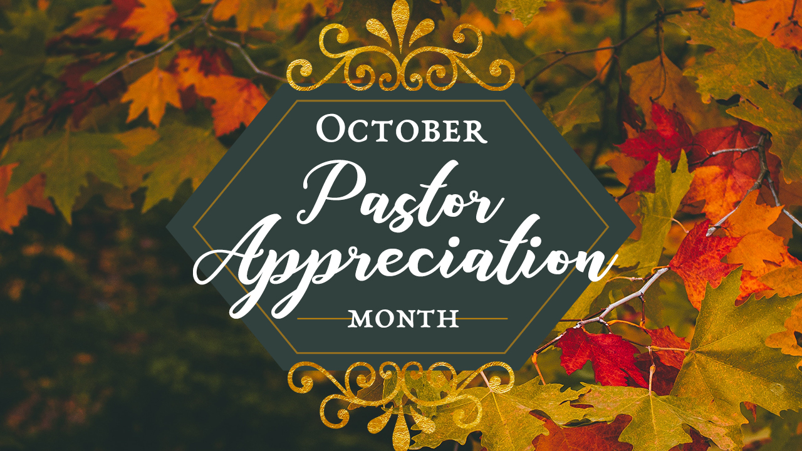

12th Rhonda Cullinan

14th Massa Bestman

Throughout the month of October,

we will be participating in the

**World Mission Offering**

Your gift is vital support for global servants and partners serving in over 70 countries.

Total offering to date: $578.00

**PRAYER** REQUESTS THIS WEEK

Annette Pickard & Family

on the death of her mother,

Janelle LaBouve

Armin Sayler

Beth Anderson, Dale & Annette Ekstrom’s daughter- treatment for brain tumor.

Bruce Rauser

Caryl Kaseman

Charlotte Martin

Donella Engstrom

Tested positive for COVID

Gary Lund

Jeff French

Ken & Shirley Quick

Tested Positive for COVID

Leo Heinz

Lynelle Kaseman (Caryl's daughter)

Pastor Bob in the hospital

with COVID

Philippe Ngoma-Hepatitis C

and autoimmune issues

Renee Herman

Scott Simpson

Scott Wittune

Judy Wittmier’s brother

Kidney chemo treatments

Steve Wonnenberg

dealing with ALS

**Church Leadership Team Meeting**

Monday, October 12th

6:30 pm



The first day of AWANA will be September 19th at 6:30

**Register on line**

**[HERE](https://bb.churchcenter.com/registrations/events/507512)**

**October 18th**

Quarterly Reports Due.

**October 25th**

Quarterly Business Meeting will be

held after the

10:00 am WorshipService



**Summer Session**

**is Over**

Fall Session begins

September 9

2020



412 Youth Group

Shirts are available

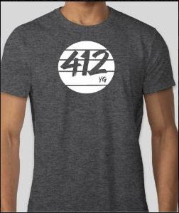

T-Shirt $15

Long Sleeved $20

Sweatshirts $25

If you are interested in ordering one, please contact Nathan

[nathan@bb.church](mailto:nathan@bb.church) or 701-425-6625



Youth Group is back!

Wednesday, August 4

7-8:30

**OVERCOMERS GALA**



October 16th, 2020

ND State Fair

Center Theater in Minot

Featuring chalk artist and motivational speaker,

Bob Upgreen.

Register by October 9th, 2020

[Register HERE for In-person Gala](https://tc4hope.ccbchurch.com/goto/forms/94/responses/new)

[Register HERE for Virtual Gala](https://tc4hope.ccbchurch.com/goto/forms/95/responses/new)



[**Watch here S*un*day at 10:00 am**](https://www.youtube.com/channel/UCx5O6q-RaCgDUppAb6kpjPg)