**First Baptist Church Weekly Newsletter**

October 18th – 24th, 2020

**Praise the Lord**

“Be thankful for what you have; you’ll end up having more. If you concentrate on what you don’t have, you will never, ever have enough.” Oprah Winfrey



**Birthdays this Week**

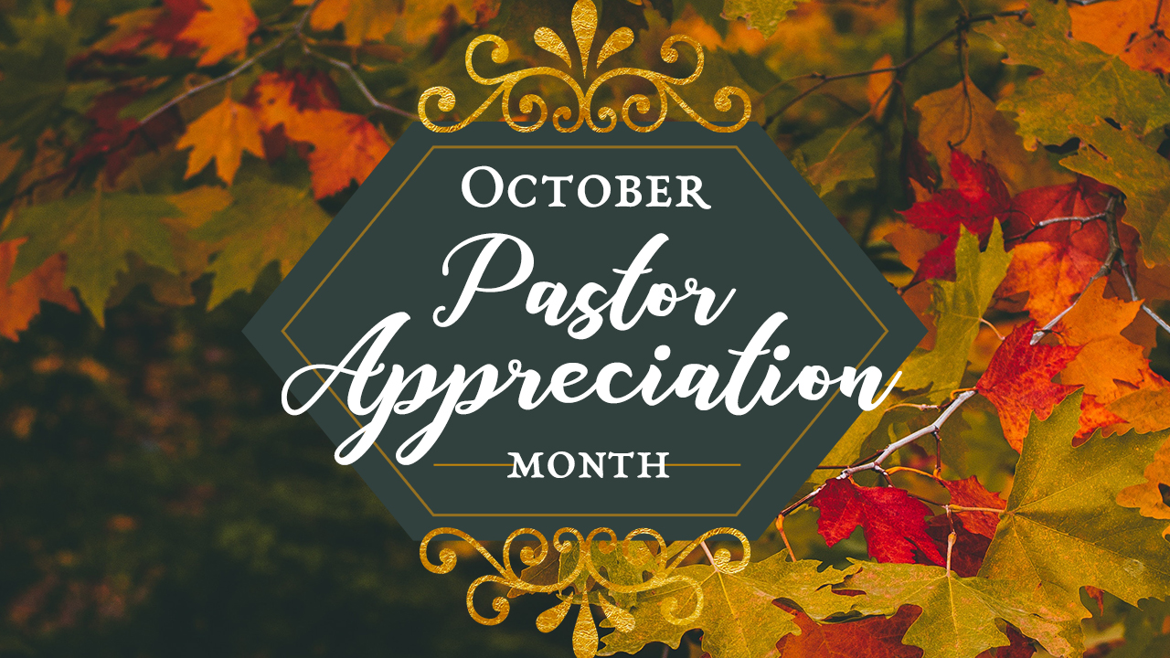

20th Karlene Fine

21st Pat Gingery

Throughout the month of October,

we will be participating in the

**World Mission Offering**

Your gift is vital support for global servants and partners serving in over 70 countries.

Total offering to date: $734.00

**PRAYER** REQUESTS THIS WEEK

Armin S.

Beth A, Dale & Annette E. daughter- treatment for

brain tumor.

Bruce R

Caryl K

Charlotte M

Donella E

Tested positive for COVID

Gary A

Tested positive for COVID

Gary L

Jeff F

Leo H

Lynelle K (Caryl's daughter)

Pastor Bob in the hospital

with COVID

Philippe N-Hepatitis C

and autoimmune issues

Renee H

Scott S

Scott W

Judy W brother

Kidney chemo treatments

Steve W

dealing with ALS

Pastor Bob can receive cards now at:

Bob Weiss

CHI ICU 3439

900 E Broadway

Bismarck, ND 58501

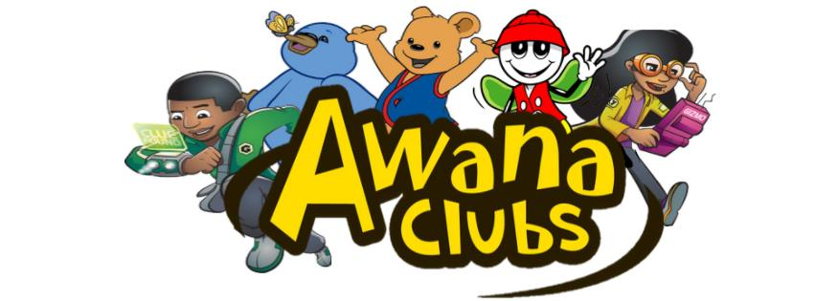

The first day of AWANA will be September 19th at 6:30

**Register on line**

**[HERE](https://bb.churchcenter.com/registrations/events/507512)**

The CLT would like the congregation to be aware of how we are handling prayer requests on Sunday mornings. Since we are live streaming and recording services, we will be doing prayers at the beginning of the services in order to protect the privacy of our members. We will start streaming after prayer time. We will also no longer be using last names in the newsletter as it is posted on our website. If you have a prayer request, please continue to email the office.

**October 18th**

Quarterly Reports Due.

**October 25th**

Quarterly Business Meeting will be

held after the

10:00 am WorshipService

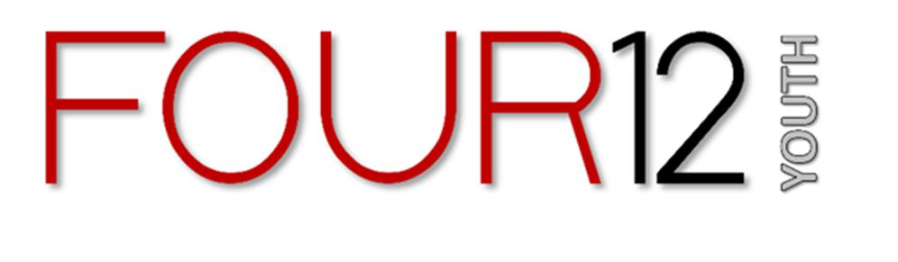

**Summer Session**

**is Over**

Fall Session begins

September 9

2020

The Church Leadership Team met this week and reviewed our procedures related to covid and we feel that with the majority of people masking, social distancing and cleaning after church use that it is safe to continue in-person worship for those who wish to attend.  On Friday, Burleigh County will be in a high risk designation which means that the maximum number of people we can have in the church at one time is 50. We have not had numbers over 50 since the church re-opened , so this  should not make a difference

for FBC at this time.

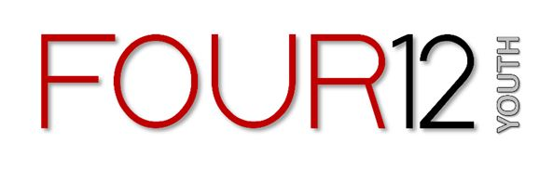

Youth Group is back!

Wednesday, August 4

7-8:30



There's no AWANA on October 21st, but we will have a game night at the church for youth from 6:30-8:30pm.

  We'll plan to do laser tag plus some time for video games, ping pong, etc.  NO dinner will be served, but there will be some pre-packed drinks and snacks.



[**Watch here S*un*day at 10:00 am**](https://www.youtube.com/channel/UCx5O6q-RaCgDUppAb6kpjPg)