**First Baptist Church Weekly Newsletter**

September 27th-October 3rd, 2020



**Birthdays this Week**



Praise the Lord

Achille NGoma has recovered from Covid and his family

has not shown any symptoms

29th Dale Ellison

29th Lori Lundblad

**WORLD MISSION OFFERING 2020**

Dear Pastor and Mission Leaders

We all find ourselves this spring and summer living through very uncertain times. As followers of Jesus Christ, sometimes the best response we can give in the face of overwhelming unknowns is to take the time to remember how each of us has experienced and known God’s faithfulness in the past.

As I think about International Ministries, the first thought that comes to my mind is how our

206 years of continued participation in the mission of God has only been possible because of God’s faithfulness to us. God has been faithful in allowing us to serve him through two world wars, the Spanish Flu, the Great Depression, 9/11, the 2008 recession, and so many other times of distress, upheaval, and loss around the world.

In each of these crises, it was not always obvious what God was up to or where God’s hand was at work. In John 11, when Jesus reaches the tomb of Lazarus and meets Mary and Martha after Lazarus’ death, the sisters are both saddened by the fact that “if you had been here, my brother would not have died.” Yet, even in this sad statement, there is a clear expression of trust and hope in Jesus.

My prayer is that this letter finds you in a place where you are able to trust Jesus to make clear in God’s time the things that perplex you.

When confronted with uncertainty, we as Christians have the opportunity to respond with faith in Jesus. I urge you to consider prayerfully how your faithful giving and prayers could be used by God at this moment to impact the lives of many in need of him around the world today…

until it is on earth as it is in heaven.

Gratefully,

Sharon Koh

Executive Director / CEO

**PRAYER REQUESTS THIS WEEK**

Anita Baillie-Health Issues

Armin Sayler Tested positive for Covid.

Beth Anderson, Dale & Annette Ekstrom’s daughter- Follow her journey with brain cancer on Caring Bridge <https://www.caringbridge.org/visit/bethanderson-joshua19>

Bruce Rauser

Caryl Kaseman

Charlotte Martin

Deanna Hedegaard-peace of mind and success on upcoming surgical procedure.

David Hansen (Mary Ann Simpson's nephew) hospitalized with Covid

Gary Lund

Jeff French’s condition has worsened, please pray for strength

Leo Heinz-recovery from surgery

Lynelle Kaseman (Caryl's daughter) Mayo appointment the week of

Sept 28th

Philippe Ngoma-Hepatitis C

and autoimmune issues

Renee Herman

Scott Simpson

Scott Wittune

Judy Wittmier’s brother

Kidney chemo treatments

Steve Wonnenberg

dealing with ALS

**Gideon Sunday**

On October 11th we will have Greg Lange as our Gideon speaker to update us on what’s happening in the Gideon ministry. If you can’t be in church and would like to support the work of the Gideons please mail a check payable to the

Gideons

PO Box 1803, Bismarck, ND 58502-1803. Lloyd will make sure our church gets proper credit for all gifts.

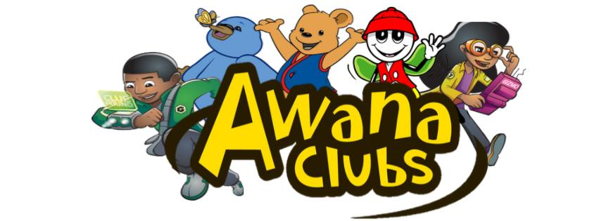

The first day of AWANA will be September 19th at 6:30

**Register on line**

**[HERE](https://bb.churchcenter.com/registrations/events/507512)**



**Summer Session**

**is Over**

Fall Session begins

September 9

2020

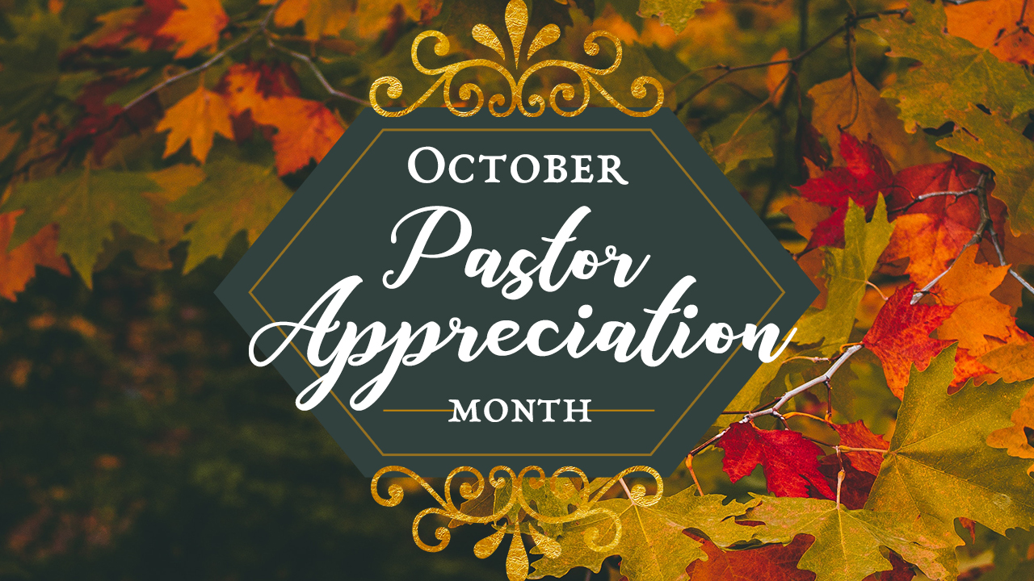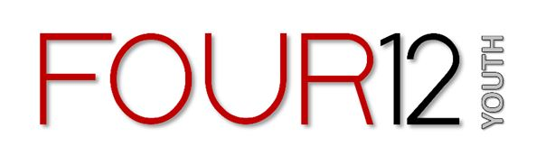

Youth Group is back!

Wednesday, August 4

7-8:30

October 18th Quarterly Reports Due.

October 25th

11 am Quarterly Business Meeting

[**Click here to watch Sunday**](https://www.youtube.com/channel/UCx5O6q-RaCgDUppAb6kpjPg) **at 10 am**

